PROJECT TITLE

STUDENT NAME

UNIVERSITI TEKNOLOGI MALAYSIA

PSZ 19.16 (Pin. 1/2023)



UNIVERSITI TEKNOLOGI MALAYSIA

DECLARATION OF THESIS/PROJECT REPORT

Author’s Full Name | :
Student’s Matric No. | : | Academic Session | :
Date | : | UTM Email | :
Thesis/Project Report Title | :

I declare that this thesis is classified as : Please tick one ( / )

OPEN ACCESS | I agree that my thesis/project report to be published as hard  copy or online open access.
RESTRICTED | Contain restricted information as specified by the  organization/institution where research was done.  (The Library will block access for up to five (5) years).
CONFIDENTIAL | Contain confidential information under Official Secret Act  1972.
(If none of the options are selected, the first option will be carried out by default)
I acknowledge the intellectual property in the thesis/project report belonged to Universiti Teknologi Malaysia and I agree to allow this thesis/project report to be placed at the library under the following terms:
- This thesis/project report is the property of Universiti Teknologi Malaysia.
- The library of Universiti Teknologi Malaysia has the right to make copies for educational purposes only.
- The library of Universiti Teknologi Malaysia is allowed to make copies of this thesis for academic exchange.

Signature of Student :
Full Name :
Date :
 | Approved by Supervisor :
Signature of University Coach : | Signature of Industry Coach :
Full Name of University Coach: | Full Name of Industry Coach:
Date : | Date :

NOTES: If the thesis is CONFIDENTAL or RESTRICTED, please attach with the letter from the organization with period and reasons for confidentiality or restriction.

“I hereby declare that we have read this thesis and in my opinion this thesis is sufficient in term of scope and quality for the
award of the degree of Bachelor of Computer Science (Data Engineering)”

Signature | :
Industry Coach | :
Date | :
Signature | :
University Coach | :
Date | :

VALIDATION OF COLLABORATION

It is verified that this project is achieved through the collaboration between

XXX (MALAYSIA) SDN. BHD.
and

UNIVERSITI TEKNOLOGI MALAYSIA

Verified by (Industry):

Signature: Date:
Name:
Affiliation: XX (MALAYSIA) SDN. BHD.
Official stamp:

Verified by (University):

Signature:
Name: Date:
Affiliation: UNIVERSITI TEKNOLOGI MALAYSIA
Official stamp:

TITLE

NAME

A thesis submitted in fulfilment of the
requirements for the award of the degree of
Bachelor of Computer Science (Data Engineering)

Faculty of Computing
Universiti Teknologi Malaysia

JANUARY 2025

DECLARATION

I declare that this thesis entitled “title “ is the result of my own research except as cited in the references. The thesis has not been accepted for any degree and is not concurrently submitted in candidature of any other degree.

Signature | : | ....................................................
Name | :
Date | :

DEDICATION

This thesis is dedicated to my father, who taught me that the best kind of knowledge to have is that which is learned for its own sake. It is also dedicated to my mother, who taught me that even the largest task can be accomplished if it is done one step at a time.

ACKNOWLEDGEMENT

In the acknowledgements section, the author expresses gratitude to those who have provided personal and professional support throughout the thesis writing process. It is acceptable to use a more informal style and first-person pronouns than is typically permitted in academic writing. Acknowledgments are not considered part of the academic work itself; rather, they are an opportunity for you to express yourself in a more personal manner. The thesis acknowledgements should not exceed one page.

ABSTRACT

A thesis abstract concisely summarises the research conducted by describing the objectives, methodology, significant findings, and conclusions of the study. It serves as a stand-alone representation, allowing readers to rapidly ascertain the thesis's essence and significance, thereby influencing their decision to investigate the document further. The abstract is instrumental in conveying the significance and contributions of the thesis to the academic community and broader audience.
In general, an abstract includes the following:
(a) A brief theme sentence about the overall issue addressed in the thesis.
(b) The main aim or purpose of the study.
(c) The academic and practical importance of the study.
(d) The methodology used in the study.
(e) The main finding(s) of the study.
(f) A concluding statement to indicate the contribution made by the study.
(g) The practical or managerial implications of the study.
The abstract must consist of a single paragraph on one page. The length should be approximately 300-500 words. It should be indented and formatted with either single or 1.5 line spacing. The abstract must be composed in both English and Bahasa Melayu. For a thesis written in Bahasa Melayu, the abstract must first be written in Bahasa Melayu and followed by an English translation. If the thesis is written in English, the abstract must be written in English and followed by a translation in Bahasa Melayu.

ABSTRAK

translation abstract in Bahasa Melayu.

TABLE OF CONTENTS [EXAMPLE]

TITLE PAGE

CHAPTER 1 INTRODUCTION 1
1.1 Introduction 1
1.2 Problem Background 1
1.3 Project Aim 6
1.4 Project Objectives 6
1.5 Project Scope 7
6.1 Project Importance 8
1.6 Report Organization 8

CHAPTER 2 LITERATURE REVIEW 9
2.1 Introduction 11
2.2 Related previous study no Sentiment 11
2.3 Literature Review of Related Theory Used 12
2.4 Literature Review of Technology Used 12
2.5 Chapter Summary 12

CHAPTER 3 METHODOLOGY 13
3.1 Introduction 18
3.2 Methodology Choice and Justification 18
3.3 Phases of the Chosen Methodology 18
3.4 Technology Used Description 18
3.5 Chapter Summary 18

CHAPTER 4 ANALYSIS AND DESIGN 19
4.1 Introduction 27
4.2 System Architecture 27
4.3 Requirement Analysis 27
4.4 Project Design 27
4.5 Database Design 27
4.6 Interface Design 27
4.7 Chapter Summary 27

CHAPTER 5 IMPLEMENTATION AND TESTING 29
5.1 Introduction 33
5.2 Coding of System Main Functions 33
5.3 Interfaces of System Main Functions 33
5.4 Testing 33
5.5 Chapter Summary 33

CHAPTER 6 CONCLUSION 35
6.1 Introduction 36
6.2 Achievement of Project Objectives 36
6.3 Suggestions for Future Improvement 36

LIST OF TABLES
TABLE NO. TITLE  Table 2.1 Error! Bookmark not defined.  Table 2.2 Error! Bookmark not defined.  Table 2.3 Error! Bookmark not defined.  Table 4.1 28  Table A.1 Error! Bookmark not defined. | PAGE

LIST OF FIGURES

FIGURE TITLE PAGE
NO.

Figure 2.1 Error! Bookmark not defined.
Figure 3.1 Error! Bookmark not defined.
Figure A.1 Error! Bookmark not defined.

LIST OF ABBREVIATIONS
ANN | - | Artificial Neural Network
GA | - | Genetic Algorithm
PSO | - | Particle Swarm Optimization
MTS | - | Mahalanobis Taguchi System
MD | - | Mahalanobis Distance
TM | - | Taguchi Method
UTM | - | Universiti Teknologi Malaysia
XML | - | Extensible Markup Language
ANN | - | Artificial Neural Network
GA | - | Genetic Algorithm
PSO | - | Particle Swarm Optimization

LIST OF SYMBOLS
δ - Minimal error
D d, - Diameter
F - Force ^{v} - Velocity ^{p} - Pressure
I - Moment of Inersia
r - Radius
Re - Reynold Number

LIST OF APPENDICES

APPENDIX TITLE PAGE

Appendix A 40
Appendix B 41
Appendix C 42

CHAPTER 1

INTRODUCTION

Introduction

Introduction is an important chapter because it outlines the whole project and outcome. This is the first chapter that the examiners will read; hence giving a solid first impression is vital. A well written chapter will clearly describe the flow of the project. To have a well written chapter, a good understanding of the ground work is necessary

Problem Background

Example:
Explain what is the current system problem such as added a new user requirement.
How to identify the problem?
Identifying problems is a crucial process in a FYPi project. The following exercise will show a step-by-step guide in identifying the problem.

Step 1: Find the problem that needs solving, as such:
- Problem given by the industry coach. It could be related to an organization, a community, a process or a procedure. The industry coach will provide the basic problem based on the real world and perhaps some ideas for a possible solution. The students can proceed from here.
- If the problem is not presented in a neat package, students themselves need to identify the problem domain. For example, Hospital System in XYZ– how it works? How are the patients tracked currently? Can student propose an improved system? Do student think the new system would be better? Now that the problem is identified, let’s move on to the next step.
Step 2: Decide on what to do as this will determine the scope of the project.
Option 1: Do the student wants to develop a new enhanced system? If yes, follow the system development track.
Option 2: Do the student think that the current possible solutions in the market are not enough, and want to research a new way? If yes, follow the research track
Now follow the option that is selected. Refer to Table 1.1 for the example.

Table 1.1: Example of Formulating a Problem
System Development Based Project
- Study the current system and procedure in implementation at the mental hospital in Johor (for example)
- Study the available systems and procedure in other mental hospitals
- Study similar tracking systems that are available (e.g. UPS tracking of parcels)
- How to study? These methods (or instruments) may be followed:
  - Document analysis
  - Interview
  - Observation
  - Survey
- Proposing currently available technologies? Which will be best suited for the aim of the project (i.e. tracking the patients)
  - Cloud technology
  - Business intelligent (BI)
  - Sensors
  - Buddy System
- Say that BI is chosen. The possible questions that need to be addressed:
  - Why BI? How does BI help with solving this problem?
  - How does BI function?
  - What are the hardware and software requirement?

Step 3: Formulate the scaffold of the problem solving by identifying the following points:
- Problem background
- Problem statement: (where needed, you can have: hypothesis, research question)
- Objective
- Scope and assumption
- Significance of project/research

Project Aim

- A single sentence statement.
- Explaining the key target of the project.
- Example:
The aim of this project is to develop a dashboard for the XXX.

Project Objectives
- A minimum of three objectives and a maximum of four.
- Must be measurable

Objectives must be measurable and focused to the project. Measurable means that the outcome is clear. For example, if the objective is “to study”; the outcome will be a comparison table of several technologies. An example of an objective that cannot be measured is “to help”. Help is very subjective, and it is difficult to detect the level that help has been given. Even the explanation is confusing, so this is not a good choice for an objective.

A generic example for the objectives is as follows, and it should be linked with the project:
- Identify and study the problem domain; current and available technologies/system
- To analyze..
- To design..
- To implement the proposed solution/system
- Test the developed solution/system for system performance and user acceptance
Table 1.2 shows the list examples of good objectives and examples of common mistakes that students often do when writing the objectives of their projects.

Table 1.2: Example of bad and good objectives statements for system development
Bad Objective | Good Objective
- To study business intelligent  - To understand methods of business intelligent  Comment:  Both of above objectives are not measurable. | - To compare the methods of business intelligent in XXX; current and available technologies/system  - To design and implement the proposed solution/system  - To test the developed solution/system for system performance and user acceptance
- To use Power BI in developing the system.  (This statement is a scope)  - To improve the speed of the overall system performance.  (This statement is an aim of the project) | - To design (database/interface) using (technology/algorithm/method) – can be more than one design of subcomponents of system X.  - To develop a system based on the design. (Example: web, cloud, system, server, client, integration.)

Project Scope

- Describes in detail tasks to be executed.
- Constraints regarding any part of the project development (e.g. size of system and technology).
- What will and will not be done as part of the project.
Example of the scopes of the project are:
- This project involves creating a Power BI report dedicated to organize ticket management for XXX
- The process involves are data extraction from XXX, followed by data transformation processes to ensure the data is clean, consistent, and ready for analysis.

Project Importance

Importance of the project describes the justification of importance of a project. In essence, it is to explain why this project should be done and how it will solve the problem, while contributing to the targeted audience or domain.

Report Organization

This report is organized into distinct chapters to provide a structured presentation of the project.

CHAPTER 2

LITERATURE REVIEW

In Chapter 2, all the results and findings of the review of literature are presented. Literature review provides a sound basis for a good problem formulation and planning of project. From the literature review, student will be able to build the basic understanding of the project.

How to Start the Literature Review?

Literature review is a survey of scholarly sources on a specific topic. It provides an overview of current knowledge, allowing you to identify relevant theories, methods, and gaps in the existing research that you can later apply to your FYPi thesis
Table 2.1 shows the example of Chapter 2

Table 2.1 : Example of Chapter 2 of the FYPi report
System Development Based Project | Research Based Project
Chapter 2 : Literature Review  2.1 Introduction  2.2 Fundamental Theory & Concept  2.3 Related Previous Researches/ Systems/ Compare between existing systems / Ensure strength and weakness between systems  2.4 Technology Used  2.5 Summary | Chapter 2: Literature Review  2.1 Introduction  2.2 Related Theory/Concept  - Study of domain from general to specific  - Related studies  - A description of the identified problem  - Study of theory/algorithm/method that  2.3 Summary

CHAPTER 3

METHODOLOGY

The methodology chapter of the FYPi report (Chapter 3) describes the way or method of implementing the project. The chapter is crucial in planning the project to ensure a successful implementation. This guideline given here will provide essential help for students to have a well-written Methodology chapter of the FYPi report.
Methodology describes the overall approach and framework chosen for system development and research. The content for the methodology chapter of the FYPi report can hold methods, techniques or approach that is used during planning, analysis, design and implementation of the project. In addition, this chapter also justifies the choice of methods or approach, as well as hardware and software requirements. It must be noted that the primary objective is not to explain the functions of each phase but rather the process that goes on within in. Table 5.1 shows the outline of Chapter 3 of the FYPi report. This outline must be followed, although slight modifications that enhance understanding of the project are accepted.

Table 5.1: Example of Chapter 3 of the FYPi report
System Development Track
Chapter 3: System Development Methodology
3.1 Introduction
3.2 Methodology choice and justification.
3.3 Phases within the chosen methodology (traditional or modern)
- Describes activities and process apply in this project for each phase
- Design modelling (e.g. using UML)
- Design tools (e.g. Rational Rose)
- Gantt Chart
- Describe briefly the technology or tools used to develop the system.
3.5 System requirement analysis: hardware and software
● List and justify
3.6 Chapter summary

Research Track
Chapter 3: Research Methodology
3.1 Introduction
3.2 Operational Framework/Research Workflow
- Details of each research phase of with regards to research objectives.
- Gantt Chart for FYPi1 and FYPi2
3.3 Justification
- Tools
- Data
- Technique
  - Performance Measurement
3. 5 System requirement analysis: hardware and software
● List and justify
  - Chapter summary

A software development methodology refers to the framework that is used to structure, plan, and control the process of developing software. The framework of a software development methodology consists of:
- A software development approach that consists of systematic software development process
- Software development models to assist in the software development process
- Software development tools

Software development approach is divided into two categories: traditional and modern approach. Examples of the traditional approach are Waterfall and Prototyping, while an example of a modern approach is Rational Unified Process.

Any approach selected to be used in the project must be justified. For instance, a Waterfall model is suitable to be used for the following types of project:

- Project is for development of a mainframe-based or transaction-oriented batch system.
- Project has clear objectives and solution.
- Project requirements can be stated unambiguously and comprehensively.
- Project requirements are stable or unchanging during the system development life cycle.

In some situation, a Waterfall system development approach is not suitable to be applied. The types of projects are as follows:

- Large projects where the requirements are not well understood or are changing for any reasons such as external changes, changing expectations, budget changes or rapidly changing technology.
- Real-time systems.
- Event-driven systems.
iv. Leading-edge applications.

Projects that are suitable to apply prototype system development approach are as follows:
- Project is for development of an online system, requiring extensive user dialog, or for a less well-defined expert and decision support system.
- Project is large with many users, interrelationships, and functions, where project risk relating to requirements definition needs to be reduced
- Project objectives are unclear.

However, the following projects might not suitable to apply prototype system development approach:
- Mainframe-based or transaction-batch oriented system
- Project objectives are very clear;

The following projects might want to consider applying Rational Unified Process (RUP) (i.e. modern system development approach):
- Large projects where requirements are not well understood or are changing due to external changes, budget changes or rapidly changing technology.
- Web Information systems iii. Real-time or safety-critical systems iv. A high degree of accuracy is essential
- Computationally complex systems, where complex and voluminous data must be analyzed, designed and created within the scope of the project.
- Leading edge applications

For software model, students could use traditional method such as Entity Relationship Diagram (ERD) or choose to use Unified Modeling Language (UML) to represent their proposed system. At least the following components must be presented in the report/thesis as part of project’s requirement analysis: i. Use case diagram ii. Sequence diagram iii. Overall system architecture

Research
A research framework is a collection of interrelated steps or processes but not necessarily so well worked-out. The framework provides logical steps in guiding the research such as determining what things will be delivered, measured, what are the inputs to each steps and outputs of the research. An example of research framework is shown in Figure 5.1 below.
Mengkaji graphical password
yang sedia ada
Mengkaji jenis
-
jenis permainan
-

Ciri
-
ciri dan jenis
-
jenis graphical
password
-

Keselamatan dan kebolehgunaan
-

Ciri
-
ciri permainan yang sesuai
digunakan
Rekabentuk dan membangunkan
eksperimen
Menjalankan eksperimen
Hasil eksperimen
FASA
1
FASA
2
Analisis hasil eksperimen
Dokumentasi
FASA
3

Figure 5.1: An example of research framework

iii. Data analysis and measurement techniques basically depend on the research nature and the research question. Some examples of data analysis are finding the average, median, standard deviation and the distribution. The results from the analysis can be presented in form of graphs (pie graphs, bar graphs, line graphs and etc), tables (values, percentage), matrices and etc.
iv. Performance measurement is used to benchmark the result of the work with other existing similar works. Examples include speed, overhead, recall, precision and accuracy. In some cases this can be used to indicate the success of the research.

CHAPTER 4

ANALYSIS AND DESIGN

This chapter focuses on the design chapter of the FYPi report that is Chapter 4. Design is important because it differentiates from one project to another, and a mishap in design will spell failure in achieving the project objectives. This guideline will serve the purpose to demystify the design process.

Content of Analysis: System Requirement Analysis

Systems analysis is the process by which an individual (s) studies a system such that an information system can be analyzed, modeled, and a logical alternative can be chosen. Systems analysis projects are initiated for three reasons: problems, opportunities, and directives.

The Content of Design Chapter

Design will outline the flow and modules in system development and research respectively. A good design will aide in a successful implementation of the project. In SCSP 4233 the design chapter will chart a provisional design that may require review as the project gets underway. In SCSP 4234, the design chapter reports the design of the completed system. The content will include system architecture, interface design, database design, and the related/appropriate techniques and algorithms. This chapter will also contain Data Flow Diagram (DFD), use case diagram, sequence diagram, class diagram, ERD and others, associated with the application development model chosen (structured or object-oriented). Table 4.1 and Table 4.2 shows example outline of Chapter 4 of the FYPi report.

Table 4.1: Example of Chapter 4 of the FYPi report
System Development Track
Chapter 4: Analysis and Design (SECP 4223/SECP4234)
4.1 Introduction
4.2 System Analysis
4.2.1 Case Study
4.2.2 Company Organization Structure
4.2.3 System Requirements Gathering Techniques (such as interview etc)
4.3 System Requirements
4.3.1. Functional Requirements
4.3.2. Non Functional Requirements
4.4 Current System Analysis (Manual/any improvement)
Flow chart for current system
4.5 System Design
4.5.1 System Architecture
System Architecture (System Flow, Module, Input, Output)
4.5.2 Explain each component in system architecture
4.5.3 System Design
- OOP (use case, sequence, and activity diagrams) or
- System/Process Design o UML (Use case, Sequence etc)/DFD
- Traditional (Software Development Life Cycle)
- Data Engineering Process
- Data Source
- Extraction/Transformation/Loading

4.5.4 Database Design
- ERD (for traditional methodology)
- Normalized tables (to include primary key, foreign key, etc.)
- Non-SQL Design
- SnowFlake/Star Schema (Data Warehouse/Data lake)
4.5.5 Interface Design
- Menu and screen design
- System navigation and content design
- For web page project to include page navigation
- Dashboard
- Chart and dashboard design
4.5.6 Summary

Table 6.2: Example of Chapter 4 of the FYPi report
Research Track
Chapter 4: Research Design and Implementation (SECP 4223/SECP4234)
4.1 Introduction
4.2 Proposed Solution
- Explain possible solution
4.3 Experiment design
- Identify overall flow
- Identify and explain test-bed/simulation setup
4.4 Parameter and testing methods
- Identify parameters involved
- Identify parameters to be measured
- Explain how testing is done
4.5 Chapter summary

Example of System Architecture
Example: Scalable order processing https://learn.microsoft.com/en-us/azure/architecture/examplescenario/data/ecommerce-order-processing

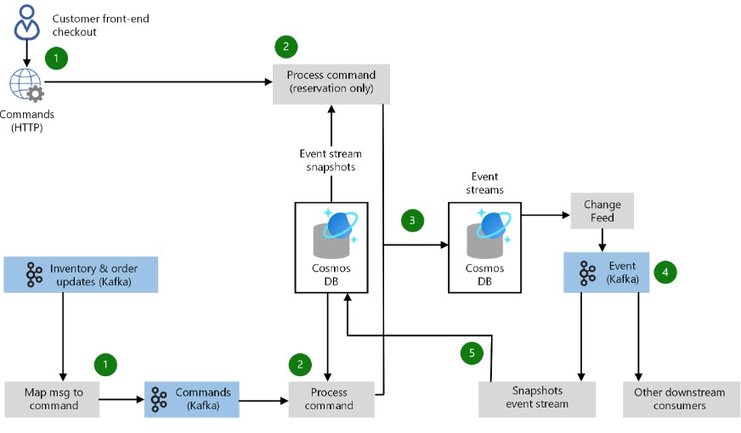
Example: Scalable Data Analytics Pipeline https://www.freecodecamp.org/news/scalable-data-analytics-pipeline/

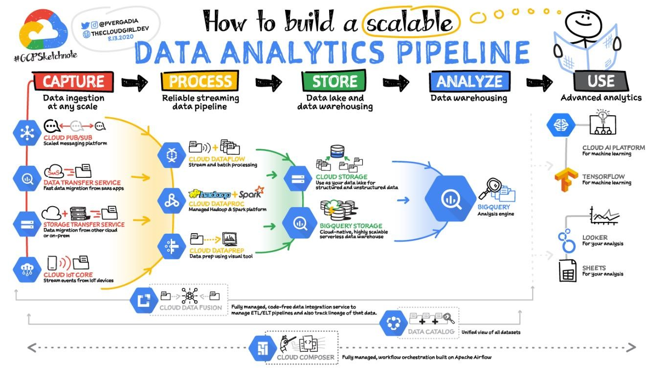
Example: Architecture for Big Data analysis
https://www.opensourceforu.com/2017/09/open-source-tools-you-can-use-to-handlebig-data/

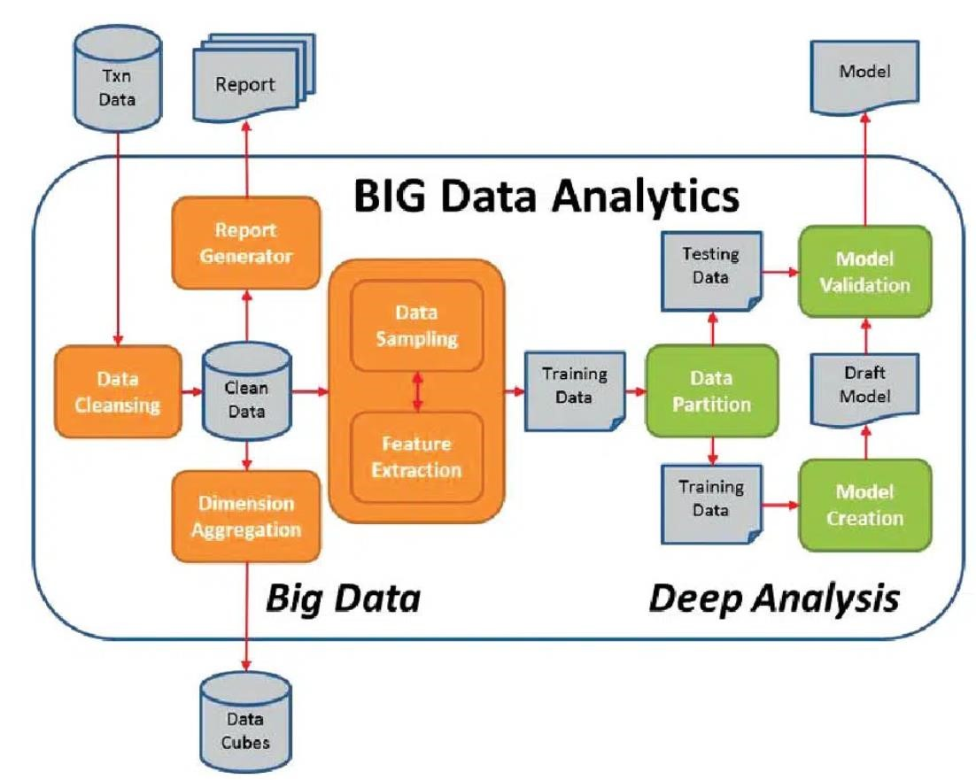
Coding of System Main Functions

Additional Guideline for System Development
For interface design, apart from menu, screen, content, and system navigation design, students also need to illustrate page navigation design to assist readers in understanding the overall system workflow. Examples of use case, sequence, content and page navigation designs are as illustrated in Figures 6.1 to 6.4.

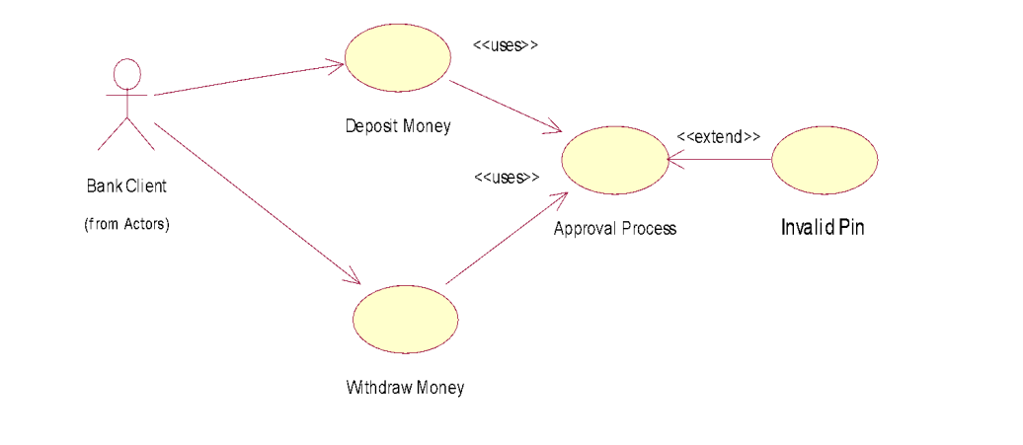

Figure 6.1: Example of Use case diagram

https://itecnotes.com/software/use-case-diagram-for-data-collection/
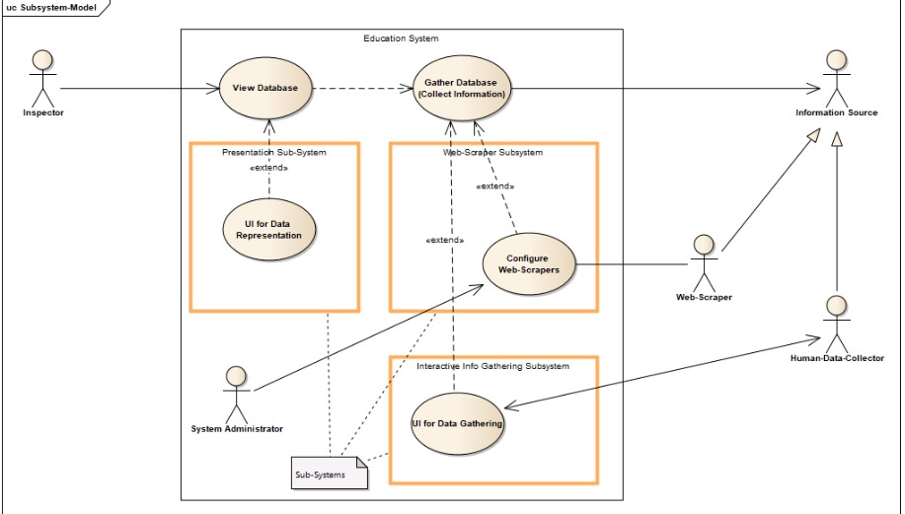
Figure 6.2: Example of Use case diagram for data collection
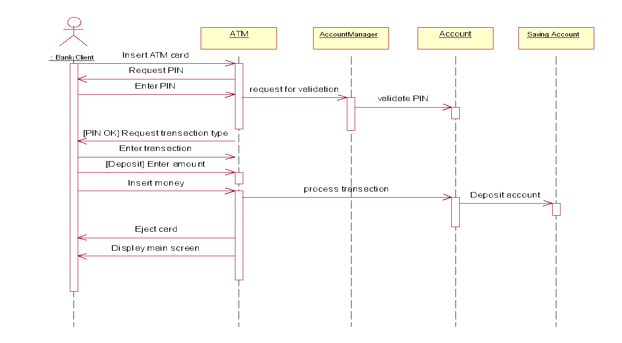

Figure 6.3: Sequence diagram

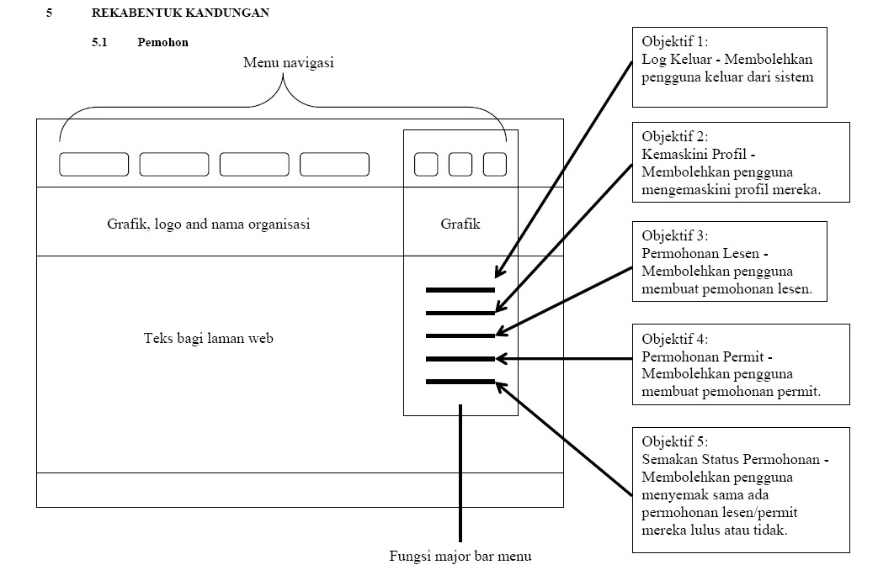

Figure 6.4: Content Design

Additional Guideline for Research
Experimental design involves elaboration on any algorithm or any instruments which may be used in the project.
All experiments were performed in a Windows machine having configurations Intel (R) Pentium( R) 4, 1.70 GHz (over 1.72 GHz), 512 MB RAM. We have used RF version (R 2.2.0) in open source R-project [19]. We have used the KDD 1999 CUP labeled dataset [6] so as to evaluate our approach. Stolfo et al. [8] defined higher level features that help in distinguishing normal connections from attacks. The dataset contains 24 different types of attacks that are broadly categorized in four groups such as probes, DoS (Denial of Service), U2R (User to Root) and R2L (remote to local). Each instance of data consists of 41 features which we have labeled as f1, f2, f3, f4 and so forth. We only used DoS type of attacks, since other attack types have very small number of instances so that they are not suitable for our experiments [15]. The dataset is consists of training set and testing set. We randomly split the set of labeled training set into two parts; learning set and validation set. Learning set is used to adjust the parameters in RF. Validation set is used to estimate the generalization error of detection model. The generalization errors are represented as OOB errors in RF. In order to achieve both low generation errors, in other words, high detection rates, we have adopted 10-fold cross validation with 2000 samples. Testing set is used to evaluate detection model built by learning set and validation set (Dong et al., 2006).

Above is a description of experimental setup extracted from a technical paper. Generally it contains, equipments used in the experiments, description of the dataset used and what are the parameters used. In the case of a project which involves a survey, it is necessary to explain the design of the questionnaire and the objective or reason for each question being asked. Sometimes, research based project may deal with modification of an existing algorithm. Therefore, it is required to show the flowchart and the pseudo codes of the modified algorithm.

Parameters used in the experiment are essential as they may affect the performance of the simulation of the proposed approach/algorithm. Therefore, they must be clearly mentioned in this chapter. Besides, there are also parameters that will be measure, for example, parameter to be measured is bandwidth, while parameters that may be involved are number of packets and types of packets.

CHAPTER 5

IMPLEMENTATION AND TESTING

This chapter discusses the process and writing of a very important chapter in the SCSP 4234 Report that is Implementation and Testing (Chapter 5). The discussion of implementation and testing is vital as it relate with the importance and achievement of the project. It is expected that student will be able to write the chapter effectively with the guide provided in this chapter.

Implementation, Testing

The implementation chapter will successfully explain all the results achieved through project coding, experiments and testing. The chapter may be expanded into more than one chapter according to the project. The results of the project implementation are discussed in detail here. Documents and proof of correctness of the project must be attached. Testing types and techniques, as well as testing results, must be stated. Table 5.1 and 5.2 shows suggested outline of Chapter 5 of the FYPi report

Table 5.1:Example of Chapter 5 of the FYPi report
System Development Based Project

CHAPTER 5: IMPLEMENTATION AND TESTING

5.1 Introduction
5.2 System development
5.3 Coding of system’s main functions
5.4 Essential interfaces that show system’s results and achievements
5.5 Testing
5.4.1 Black box testing
● System flow, input/output, error messages
5.4.2 White box testing
5.4.3 User testing
5.6 | Chapter summary

Table 5.2: Example of Chapter 5 of the FYPi report
Research Based Project
Chapter 5: Results,  5.1 Introduction  5.2 Research results and analysis  - Discussion  - Tables, Graph etc.  5.3 Chapter summary | Analysis | and | Discussion

Additional guideline for system development

Software testing is one of important phases in a system development process. There are two common testing methods, which are White Box Testing and Black Box Testing. Next section briefly describes these two software testing methods, respectively.

White box testing

White-box testing is a method of testing application software. It tests the internal structures or the workings of an application, as opposed to its functionality. White-box testing examins the internal perspective or logic of the system. This method requires programming skills to design test cases. Different input data are chosen to exercise all possible paths through the code and to determine the appropriate outputs.
White-box test design techniques include:
i. Control Flow testing / Branch Testing ii. Data flow testing (Data Tracking) iii. Path testing (Logic Testing) White-box testing can be applied at the module, integration and system levels. It can test paths within a module, paths between modules during integration, and between subsystems during a system level test. Though this method of test design can uncover many errors or problems, it might not detect unimplemented parts of the specification or missing requirements.

Black box testing

Black-box testing is a method of software testing that tests the functionality of an application. Specific knowledge of the application's code/internal structure and programming knowledge in general is not required. Test cases are built around specifications and requirements that is what the application should suppose to do. It uses external descriptions of the software, including specifications, requirements, and designs to derive test cases. The test designer selects valid and invalid inputs and determines the correct output.

Additional guideline for research

Following the research method described in the Methodology chapter, discussion should include the analysis and discussion of the results. It is encouraged that discussions are accompanied with graphs, charts or tables for enhanced clarification. Figure 7.1, figure 7.2, figure 7.3 and figure 7.4 are some examples of result presentations and discussion of the result.

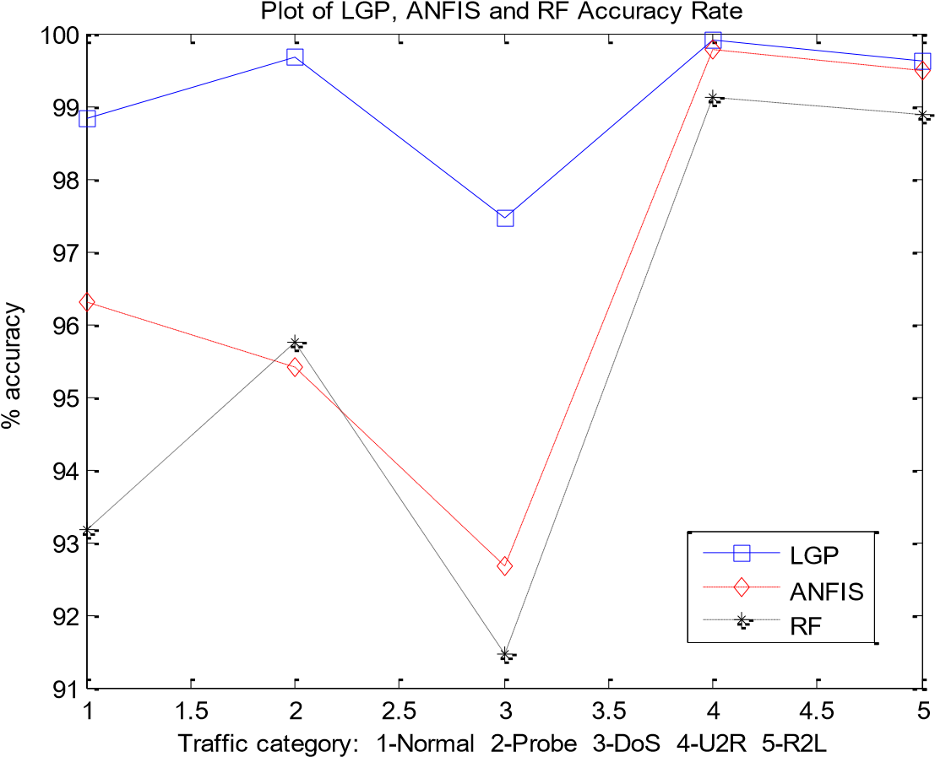

Figure 7.1: Example of a line graph

Performance Measure | Baseline(%) | RRA(%) | EA-IDS(%)
Overall Accuracy | 96.764 | 98.845 | 99.144
FAR | 16.082 | 5.591 | 2.453
Hit Rate | 99.944 | 99.948 | 99.550

Figure 7.2: Example of a table

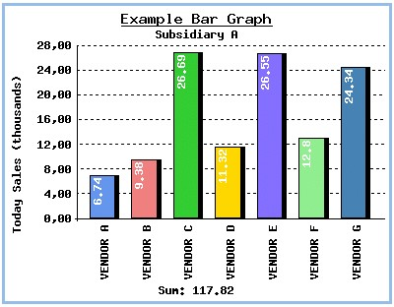
Figure 7.3: Example of a bar chart

Performance Measure Baseline(%) RRA(%) EA-IDS(%)

Overall Accuracy 96.764 98.845 99.144

FAR 16.082 5.591 2.453

Hit Rate 99.944 99.948 99.550
Generally, the overall detection accuracy has improved from 96.764% (Baseline) to 99.144% (EA-IDS) and FAR was greatly reduced from 16.082% (Baseline) to 2.453. The hit rate remains stable which is almost reaching 100% correctly ability to segregate between attacks and normal.
Figure 7.4: Example of a table with its discussion.

CHAPTER 6

CONCLUSION

This chapter focuses on the concluding in the FYPi report. Conclusion in SCSP 4233 and SCSP 4234 is handled differently. This guideline presents an effective way of concluding the FYPi report.

FYPi Conclusion Chapter (Chapter 6) summarizes the whole project undertaken by a student. It discusses results and achievements of the project as well as suggestions and future works. Project strength, weaknesses and suggestions to improve must be stated clearly and concisely.

Table 8.1: Example outline of Chapter 6 of SCSP 4233 & SCSP 4234 report
System Development Based Project
SCSP 4233  Chapter 5: Conclusion  5.1 Introduction  - Restate the project significance and objectives.  5.2 Achievements  - Briefly explain findings based on literature review  - Briefly explain any objectives that has been concluded or partially concluded  5.3 Suggested plan for project implementation/execution (SCSP  4234) | SCSP 4234  Chapter 6: Conclusion  6.1 Introduction  6.2 System Contribution/Achievement  6.3 System Constraint  6.4 Future Suggestion  6.5 Summary

Table 8.1: Example outline of Chapter 6 of SCSP 4233 & SCSP 4234 report
Research Based Project
SCSP 4233  Chapter 5: Conclusion  5.1 Introduction  - Restate the project significance and objectives.  5.2 Achievement/milestone achieved  - Briefly explain findings based on literature review  - Briefly explain any objectives that has been concluded or partially concluded  - Preliminary results (if any)  - Suggested planning for SCSP 4234 | SCSP 4234  Chapter 6: Conclusion  6.1 Introduction  6.2 Achievement of project objectives  6.3 Research Contribution (if any)  6.4 Suggestions for improvement and future works

6.1 Introduction
● Restate the project significance and objectives.

6.2 Achievement of Project Objectives
- Briefly explain findings based on literature review
- Briefly explain any objectives that has been concluded or partially concluded

6.3 Suggestions for Future Improvement
Suggested plan for project implementation/execution.

NOTES

When labeling the figures and tables in the appendices, it is recommended that it begins with the name of the appendix. For example, figures in Appendix A will be labeled Figure A1, Figure A2 and so on; while tables in Appendix A will be labeled Table A1, Table A2 and so on. It is not advisable to continue the labeling from the main text, even if the appendix is an extension of the main text. For example, if Appendix C holds the database tables that are not put into the main text in Chapter 4 (Design), it must not be labeled as Figure 4.xx.

APPENDIX

Appendices provide supporting materials that will strengthen the explanation and review of the project. Listed below are some of the generic items that may be put into appendices (please be reminded that this list is not exhaustive).
- User manual: A comprehensive guide to the developed system. It should include installation guideline, screenshots, navigation explanations and anything else that will guide the user of the system. User manuals are not a requirement for research projects.
- Supporting documents: Supporting documents can be in the form of graphs, figures, questionnaires, surveys, and interview excerpts. It is not advisable to put ALL of the questionnaires and surveys in the appendices. A better option is to put a random sample of a completed one.
- Data used in research: For research-based projects, it is at times prudent that snippets of data or the datasets used for the research is shown in appendix.

REFERENCES
Chen, M.-C. and Huang, S.-H. (2003) ‘Credit scoring and rejected instances reassigning through evolutionary computation techniques’, Expert Systems with Applications, 24(4), pp. 433–441.
Clerc, M. and Kennedy, J. (2002) ‘The particle swarm - explosion, stability, and convergence in a multidimensional complex space’, IEEE Transactions on Evolutionary Computation, 6(1), pp. 58–73.
Gosnell, M., Woodley, R., Hicks, J. and Cudney, E. (2014) ‘Exploring the Mahalanobis-Taguchi Approach to Extract Vehicle Prognostics and
Diagnostics’, in Computational Intelligence in Vehicles and Transportation Systems (CIVTS), 2014 IEEE Symposium on, pp. 84–91.
Gupta, A. (2015) ‘Classification of Complex UCI Datasets Using Machine Learning Algorithms Using Hadoop’, International Journal of Scetific & Techology Research, 4(5), pp. 85–94.
Hu, J., Zhang, L., Liang, W. and Wang, Z. (2009) ‘Incipient mechanical fault detection based on multifractal and MTS methods’, Petroleum Science, 6(2), pp. 208– 216.
Huang, C.-L., Chen, Y. H. and Wan, T.-L. J. (2012) ‘The mahalanobis taguchi system—adaptive resonance theory neural network algorithm for dynamic product designs’, Journal of Information and Optimization Sciences, 33(6), pp.
623–635.
Jain, A. K. A. K., Duin, R. P. W. and Mao, J. (2000) ‘Statistical pattern recognition: a review’, IEEE Transactions on Pattern Analysis and Machine Intelligence, 22(1), pp. 4–37.
Khalid, S., Khalil, T. and Nasreen, S. (2014) ‘A survey of feature selection and feature extraction techniques in machine learning’, 2014 Science and Information Conference, pp. 372–378.
Li, C., Yuan, J. and Qi, Z. (2015) ‘Risky group decision-making method for distribution grid planning’, International Journal of Emerging Electric Power Systems, 16(6), pp. 591–602.
Lv, Y. and Gao, J. (2011) ‘Condition prediction of chemical complex systems based on Multifractal and Mahalanobis-Taguchi system’, in ICQR2MSE 2011 - Proceedings of 2011 International Conference on Quality, Reliability, Risk, Maintenance, and Safety Engineering, pp. 536–539.
der Maaten, L. J. P., Postma, E. O., den Herik, H. J., van der Maaten, L., Postma, E. O., van den Herik, J., der Maaten, L. J. P., Postma, E. O. and den Herik, H. J.
(2009) ‘Dimensionality Reduction: A Comparative Review’, Technical Report TiCC TR 2009-005, 10(January), pp. 1–41.
Motwani, R. and Raghavan, P. (1996) ‘Randomized algorithms’, ACM Computing Surveys, 28(1), pp. 33–37.
Qinbao Song, Jingjie Ni and Guangtao Wang (2013) ‘A Fast Clustering-Based Feature Subset Selection Algorithm for High-Dimensional Data’, IEEE Transactions on Knowledge and Data Engineering, 25(1), pp. 1–14.
Rao, V. M. and Singh, Y. P. (2013) ‘Decision Tree Induction for Financial Fraud Detection’, in Proceeding of the International Conference on Artificial Intelligence in Computer Science and ICT (AICS 2013), pp. 321–328.
Shi, Y. and Eberhart, R. (1998) ‘A modified particle swarm optimizer’, 1998 IEEE International Conference on Evolutionary Computation Proceedings. IEEE
World Congress on Computational Intelligence (Cat. No.98TH8360), pp. 69–
73.
Soylemezoglu, A., Jagannathan, S. and Saygin, C. (2011) ‘Mahalanobis-Taguchi system as a multi-sensor based decision making prognostics tool for centrifugal pump failures’, IEEE Transactions on Reliability, 60(4), pp. 864–878.
Theodoridis, S., Koutroumbas, K., Holmstrom, L. and Koistinen, P. (2009) Pattern Recognition, Wiley Interdisciplinary Reviews Computational Statistics.
Zaki, M. J., Wong, L., Berry, M. J. A., Linoff, G. S., Hegland, M., Zaki, M. J. and
Wong, L. (2003) ‘Data Mining Techniques’, WSPC/Lecture Notes Series: 9in x 6in, 10(1–2), p. 545.

Appendix A

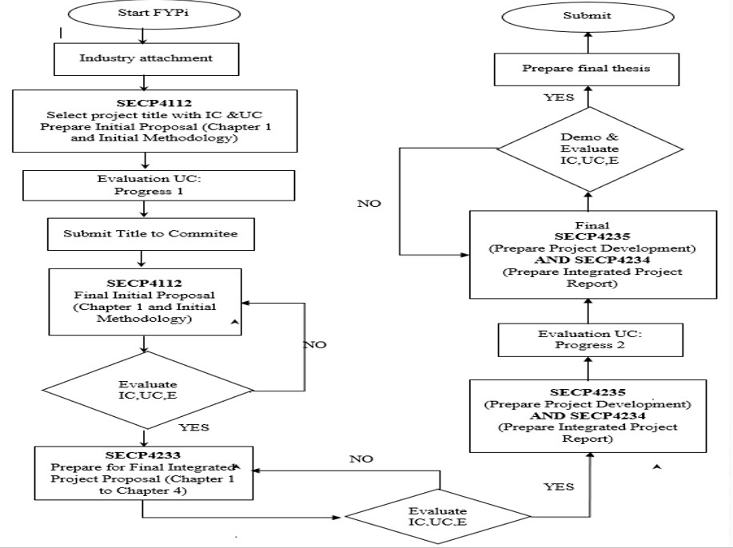

Appendix B Psuedo Code

Appendix C Time-series Results Long

